

**UNIVERSITY OF PETROLEUM & ENERGY STUDIES**

**SCHOOL OF COMPUTER SCIENCE**

***Department of Cybernetics***

**GRAPHICS AND ANIMATIONS TOOLS**

LAB FILE

SESSION(2020-21)

Course: BTech with specialization in Open Source & Open Standards

Submitted to: Submitted by:

Dr. Durgansh Sharma Mridul Thapa

Associate Professor SAP: 500060077

Department of Cybernetics Roll no: R100217*039*

**Experiment 2:**

**Step1:** Design a logo on paper with a pencil.

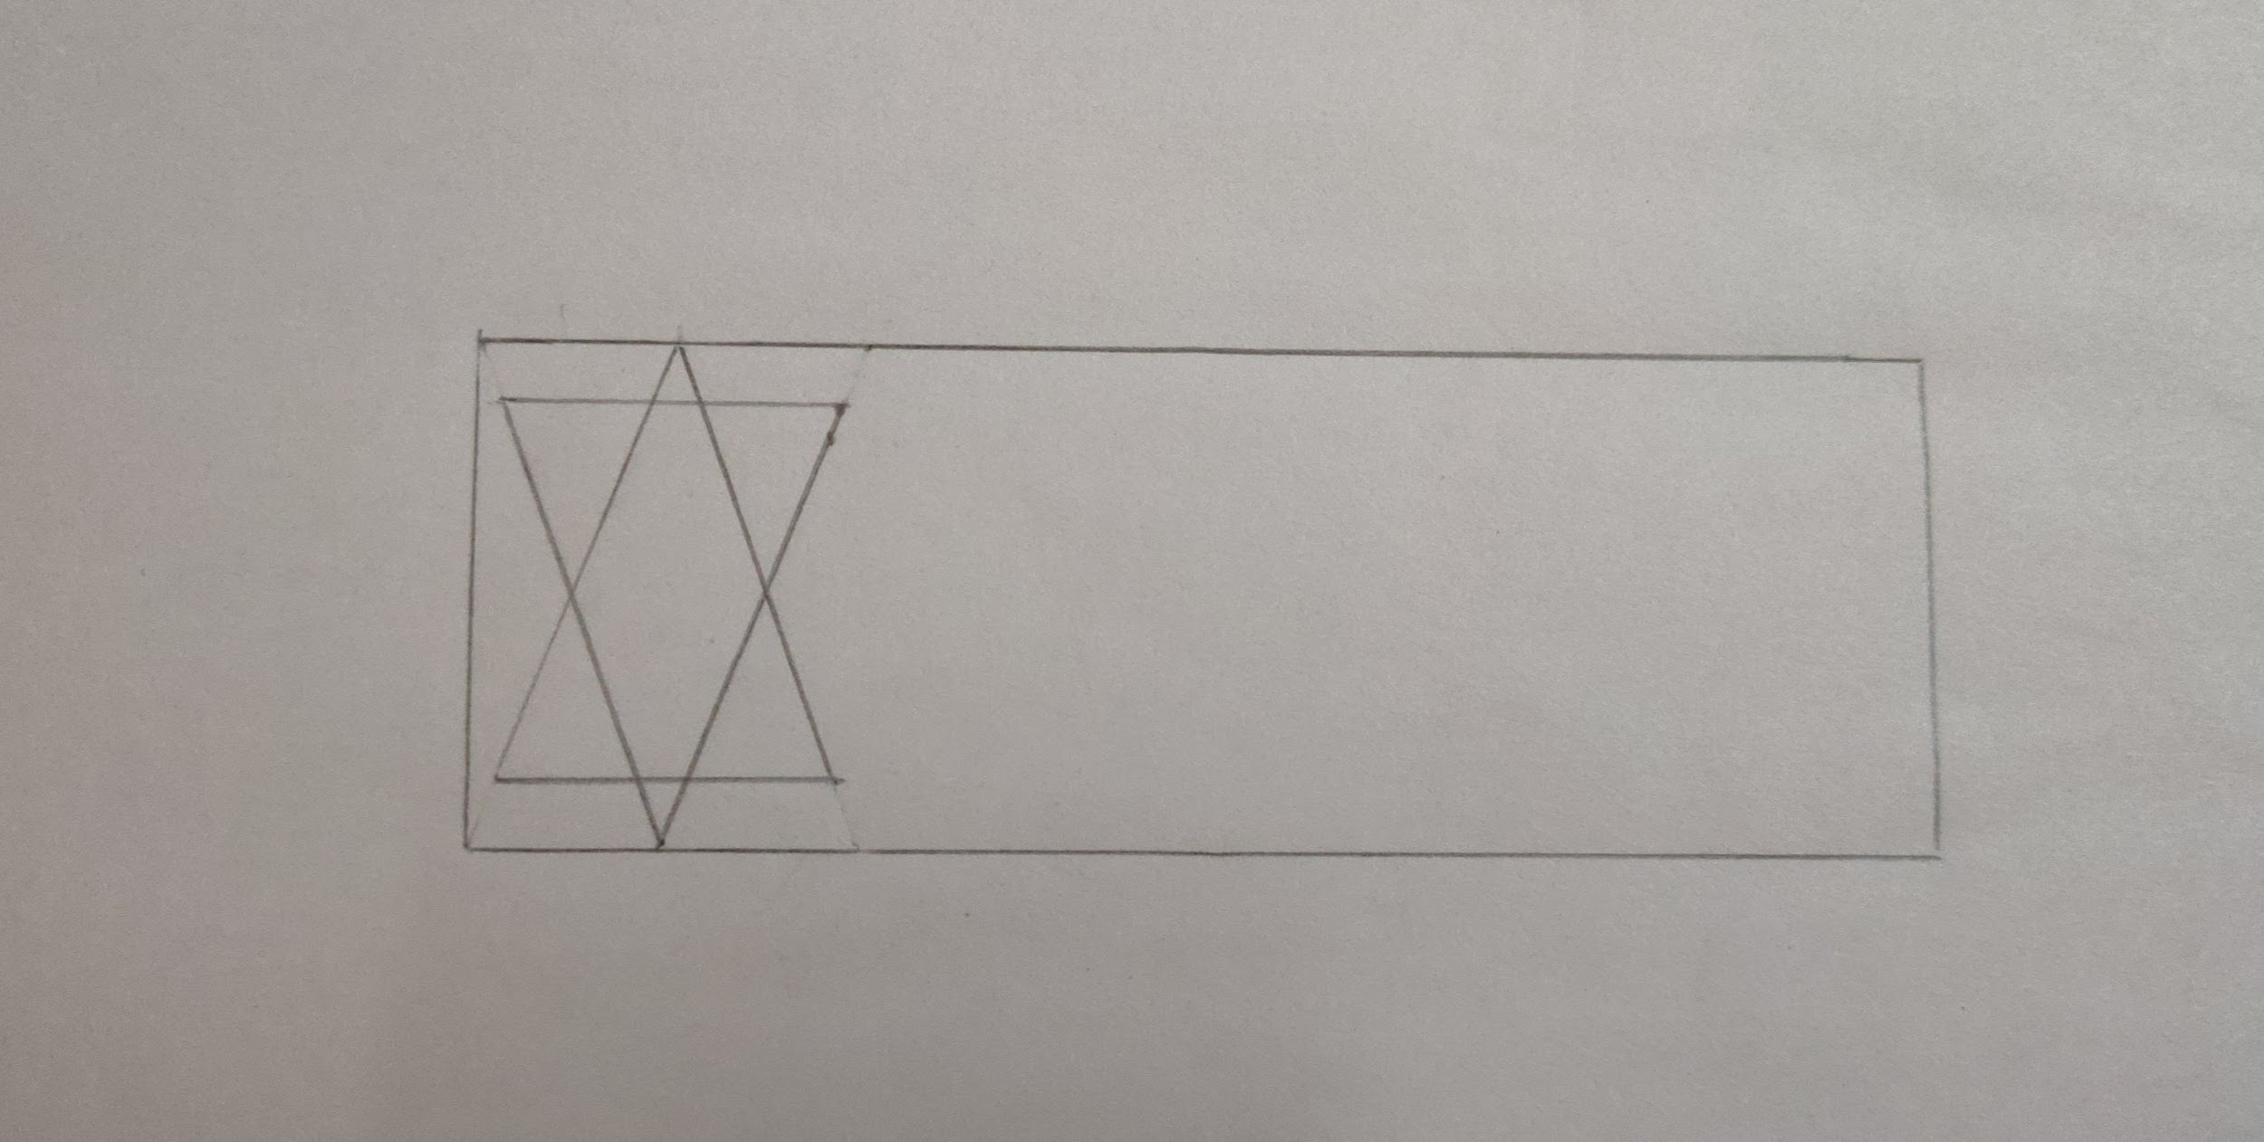

**Step2:** Open GIMP and click on New → Open as layer and open the image as above.

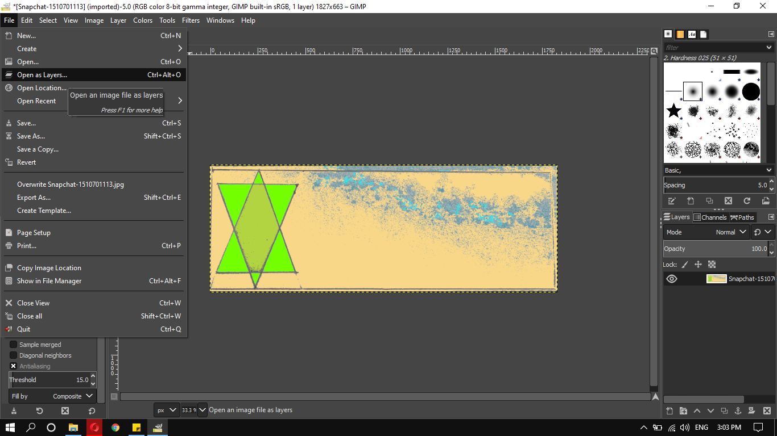

**Step3:** The image can now be edited using GIMP, add colors using the BUCKET TOOL on the toolbox.

**Step4:** After adding the colors, add the text using TEXT TOOL under the toolbox. Add other objects.

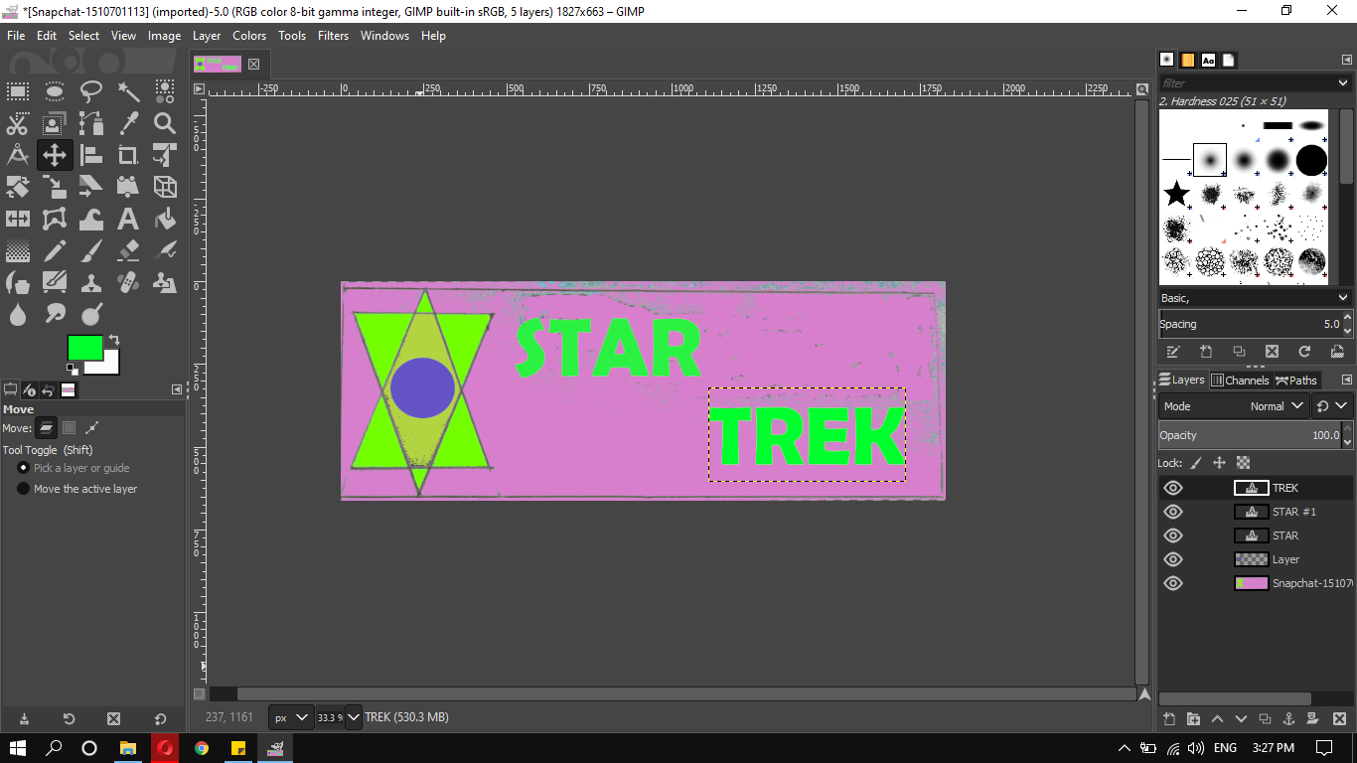

**Step5:** Export the image as .PNG or .JPG.